Conditional Logic with If else
In this lab, you will add a "brain" to our scripts using if and else.
You will teach your script to:
- Check Reality: Look if a file actually exists before trying to open it.
- Make Decisions: Do one thing if the answer is "Yes", and another if "No".
- Check ID: Verify if the user has permission (Root) to run the script.
Create a script nano check_file.sh
Paste the script :
#!/bin/bash
FILE="data.txt"
if [ -f "$FILE" ]; then
echo "$FILE exists."
fi
Make it executable : chmod +x check_file.sh
Run the script : ./check_file.sh
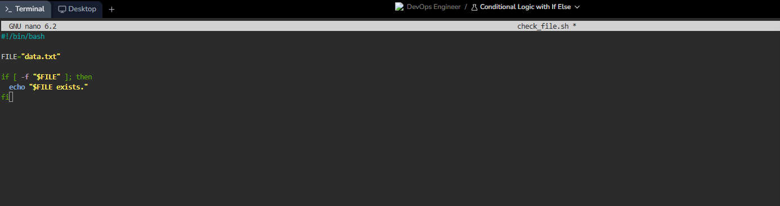

Nothing happens. Silence.

Why? Because data.txt doesn't exist. The Guard said "No", so the echo command was skipped completely.
Now we will create the file and run the command again.
Touch data.txt

Add an Else Block
Silence is confusing. If a script does nothing, you don't know if it failed or just finished. We need a Plan B.
In logic, this is the "Fork in the Road".
Path A (if): The file exists. Good.
Path B (else): The file is missing. Let's fix it.
Let's modify our script to create the missing file automatically.
First, delete the test file so we perform a real test:
rm data.txt


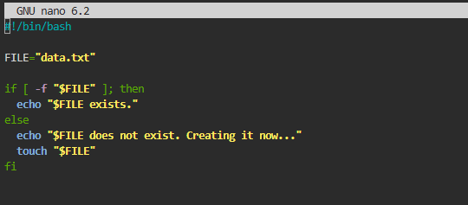
Is that not amazing!!!
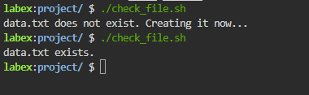
Our script is now "Idempotent"—a fancy word meaning you can run it 100 times, and it will always ensure the correct result (the file exists) without crashing.

Check for Root Permissions
Creating a smart script checks your ID card before trying to open the door.
In Linux, every user has a number (UID).
Root is always UID 0.
Normal users are usually 1000+
Open editor nano ./check_root.sh
Paste the script:
#!/bin/bash
if [ "$UID" -eq 0 ]; then
echo "You are running this script as root."
else
echo "You are running this script as a regular user."
fi
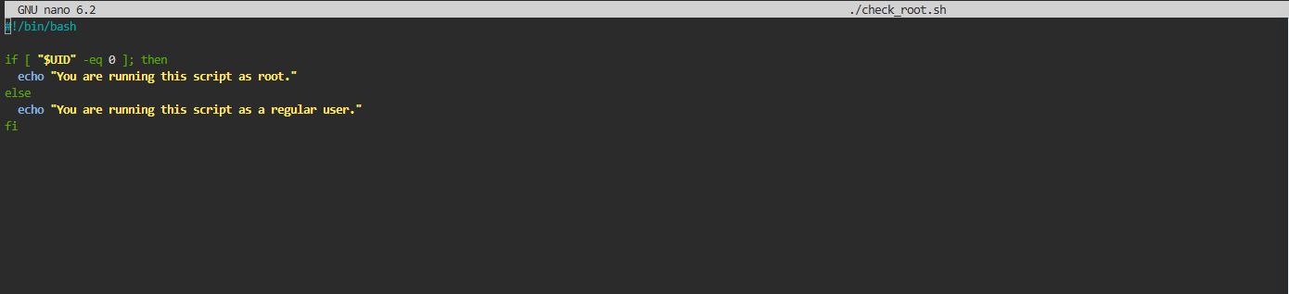
Decoding
$UID: The variable holding your current ID number.
-eq: "EQuals". (We use -eq for numbers, = for words).
Bash uses operators like -eq, -ne, -lt, and -gt. These are different from string comparisons because the shell needs to know whether it is comparing words or numeric values.
Save and Exit. Make executable:
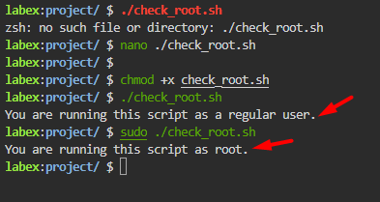
Loops with For and while
In this lab, you will build your own digital assembly lines:
- The Counter: A loop that counts for you (The for loop).
- The Worker: A loop that processes every file in a pile (The for loop with files).
- The Watcher: A loop that keeps working until a goals is met (The while loop).
Create a file nano num_loop.sh

Paste the script:
#!/bin/bash

for i in {1..5}; do
echo "Number: $i"
done
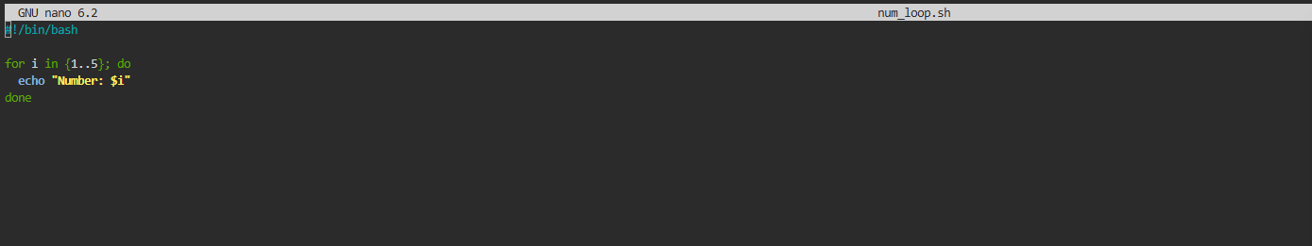
Change permission > SAVE > Execute
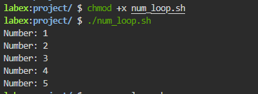

Loop with for and While
Create a file nano file_loop.sh
Paste script:
#!/bin/bash

echo "Listing text files:"
for file in *.txt; do
echo "Found file: $file"
done
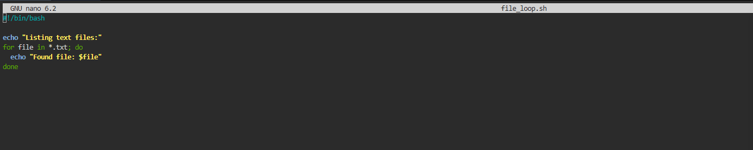
Change permission > SAVE > Execute
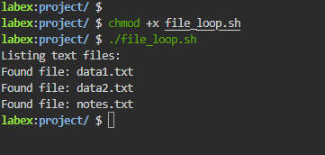

The condition loop (while loop )
Create file, change permission, save and execute.
Paste script:
#!/bin/bash
counter=1
while [ $counter -le 10 ]; do
echo "Count: $counter"
((counter++))
Done
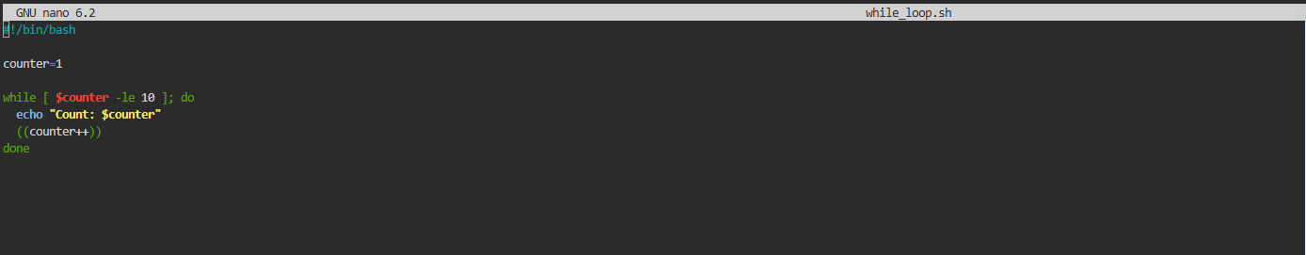
Decoding
:
while [ $counter -le 10 ]: The Condition. "Is the counter Less than or Equal to 10?"
If YES: Enter the loop.
If NO: Stop.
((counter++)): The Update. This adds 1 to the counter. Critical: If you forget this line, the counter stays at 1 forever, and the script runs forever (an "Infinite Loop")!.
